LockedMe.com
(Application Screenshots)

Author | Pooja Vishwakarma
Purpose | Screenshots of the application
Date | 13th August 2021
Version | 1.0

1. Welcome page

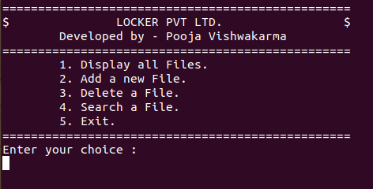

2. User enters 1 which is ‘Display all files’.

=>Application displays the total number of files present and list.

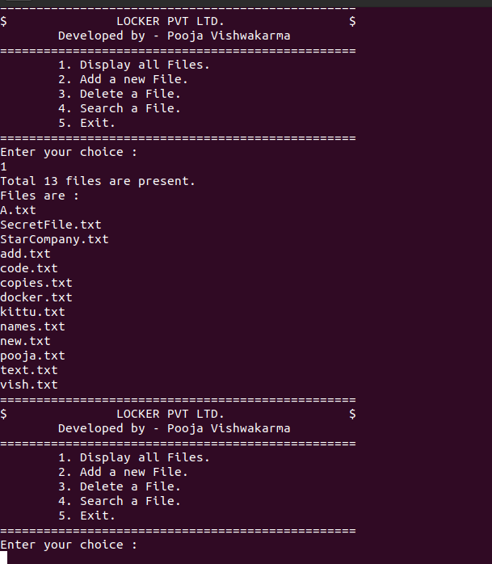
3. User enters 2 which is ‘Add a new file’

=> Application takes the file name and content from the user and saves it in locker folder.

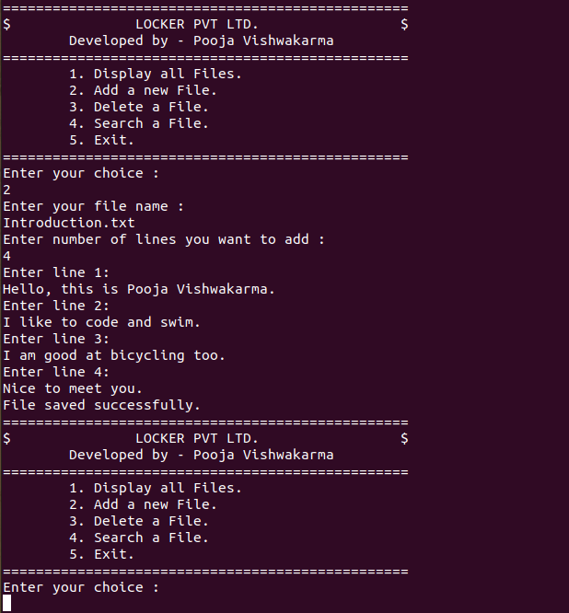

4. User selects 3 which is ‘Delete a file’.

=> Application takes file name from user and deletes it if found.

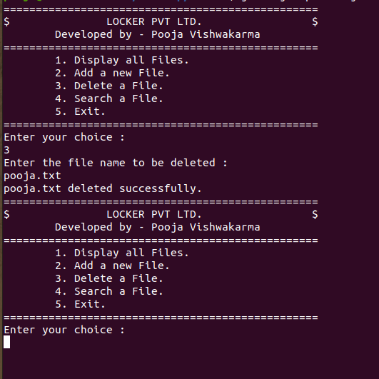

=> Application provides message if file is not deleted.

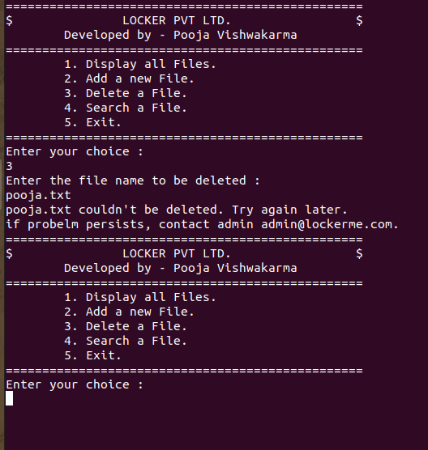

5. User selects option 4 which is ‘Search a file’.

=>Application displays message if specified file is foun in the locker folder.

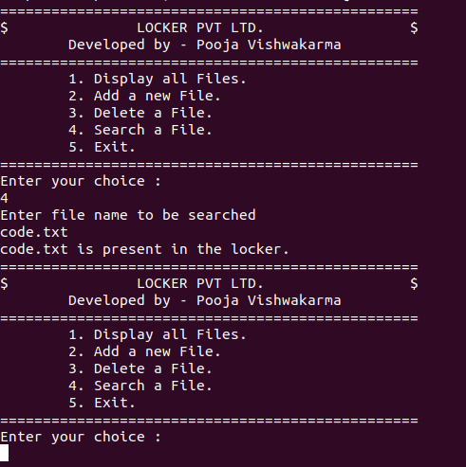

=> Application displayes message to the user if specified file is not found in the locker folder.

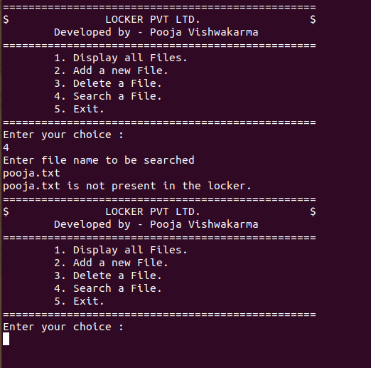

6. User selects option 5 which is ‘Exit’.

=> Application is stoppped when user enters 5.

